Practicum Case | 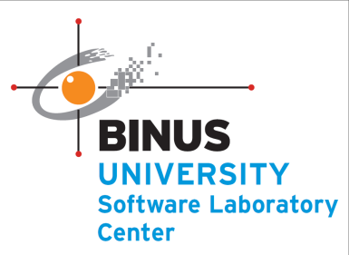
COMP7116 | COMP7116001 | COMP7116016 | MATH6168 | MATH6168016
Computer Vision
Computer Science | O211-COMP7116-TD01-01
Valid on Odd Semester 2020/2021 | Revision 00

Learning Outcomes
- Various computational principles and standard image processing operators in computer vision
- The local features with their detectors and descriptors in computer vision
- Various features to find correspondence between images and perform recognition in computer vision
- Various image recognition system in computer vision

Topics
- Session 1 – Introduction to computer vision

Subtopics
- Python Review
- Load and Show Image
- NumPy Introduction
Introduction to computer vision
Computer Vision is a field of multiple disciplines that care about how computers can gain a high-level understanding of digital images/videos. This is an attempt to automate tasks that the human visual system can perform. This is a process of acquiring, processing, analyzing, and understanding digital images, and extracting high-dimensional data from the real world (to produce numerical/symbolic information). Python on the other hand is a programming language that is currently the most prevalent, mature, and well-supported among programming languages in the area of machine learning. That is why in this course we are going to do some quick python review and introduction to several python libraries.
We will start with the provided data structures in python. These include python list, python tuple, python set, and python dictionaries.
- Python list
We can declare a list using square brackets and separate values with commas. We can put any kind of value in a list. This can be a string, a tuple, a Boolean, or even a list itself.
Figure 1. Declaring a list
To access an entire list, we can just call the name of the list. To get just one item from the list, we must use its index. However, remember that indexing begins at 0.
Figure 2. Accessing a list
The indexing we use in the code above is positive indexing. As you can see, positive indexing begins at 0 for the leftmost/first item and then traverses right. Contrary to positive indexing, there is negative indexing which begins at -1 for the rightmost/last item, and then traverses left. To get the same item from “my_list” we can look at the example code below.
Figure 3. Accessing a list with negative index
Sometimes, we may not want an entire list or a single item, but some items from it. In that case we can use the slicing operator [:]. Suppose we want items second through fourth from our list “my_list”. We can also use negative indexing in the slicing operator too.
Figure 4. Accessing a list with slice operator
Python list is mutable, which means it can be mutated, be changed. A list is mutable, so it is possible to reassign and delete individual items as well.
Figure 5. Reassigning element in a list
To append some items to our list, we can use the “append” method. And like anything else in python, it is possible to delete a list or some item within it. To delete an entire list, we can use the del keyword followed by the name of the list. But to delete a single item or slice of the list, we need its index/indices.
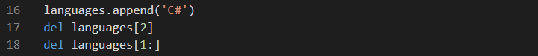
Figure 6. Appending and deleting an element in a list
- Python tuple
This python tuple is a heterogeneous container for items. The major difference between tuple and list is that a list is mutable, but tuple is immutable. This means that while we can reassign or delete an entire tuple, we cannot do the same thing to a single item or a slice. To declare a tuple, we use Parentheses. We can also pack values into a tuple without using parentheses, it is called tuple packing.
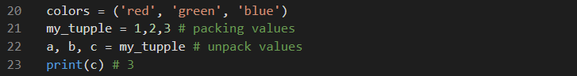
Figure 7. Accessing a tuple
We can access, reassign, and delete items on a tuple just like we can on a list. The only differences that exist are because a tuple is immutable, so you can’t mess with a single item or a slice.

- Python set
Python set is one of the important python data structures. A python set is a slightly different concept from a list or a tuple. A set, in python, is just like the mathematical set. It does not hold duplicate values and is unordered. However, it is not immutable, unlike a tuple. We can use curly brackets to declare a set.
Figure 8. Declaring a set
As you can see, it rearranged the elements in ascending order. Since a set is unordered, there is no way we can use indexing to access or delete its elements. Then, to perform operations on it, python provides us with a list of functions and methods like discard(), pop(), clear(), remove(), add(), and more. Functions like len() and max() also apply on sets.
- Python dictionaries
Python dictionary holds key-value pairs. However, you may not use an un-hashable item as a key. To declare a python dictionary, we use curly brackets. But since it has key-value pairs instead of single values, this differentiates a dictionary from a set.
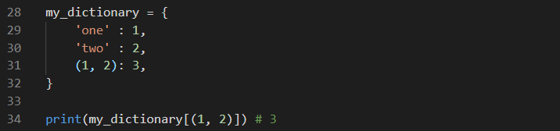
Figure 9. Accessing a dictionary
- Numpy introduction
After we have done with our quick python review, we will get into our first python library introduction. NumPy is a python package. It stands for ‘Numerical Python’. It is a library consisting of multidimensional array objects and a collection of routines for processing of array.
The most important object defined in numpy is an N-dimensional array type called ndarray. It describes the collection of items of the same type. Items in the collection can be accessed using a zero-based index. Any item extracted from ndarray object is represented by a python of one of array scalar types. The basic ndarray is created using an array function in numpy as follows.
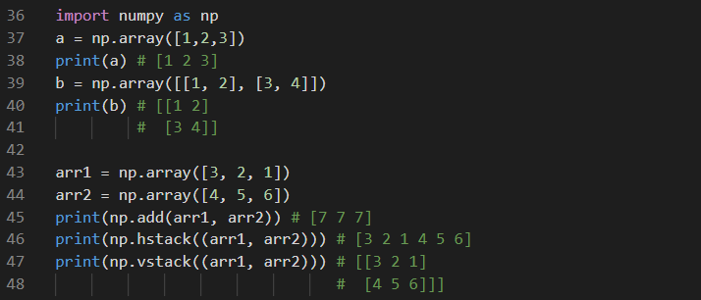
Figure 10. Declaring ndarray
Often, the elements of an array are originally unknown, but its size is known. Hence, it offers several functions to create arrays with initial placeholder content. These minimize the necessity of growing arrays, an expensive operation. The function such as zeros() creates an array full of zeros, the function ones() creates an array full of ones, and the function empty creates an array whose initial content is random and depends on the state of the memory. By default, the dtype of the created array is float64.
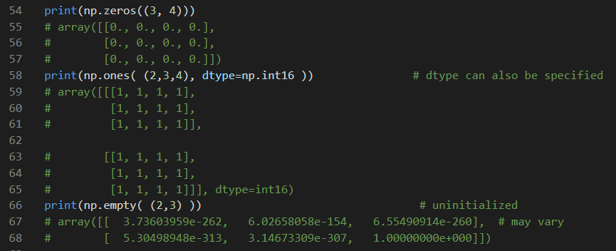
Figure 11. Using numpy functions
We can also do an operation to our ndarray using the provided function or even by using basic operators.
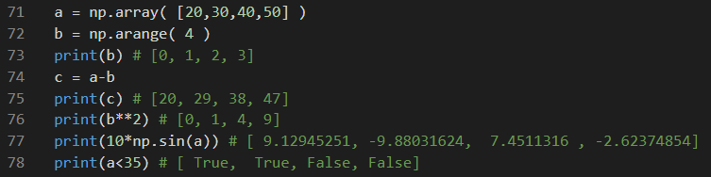
Figure 12. Using basic operation to ndarray
Numpy provides a lot of mathematical functions such as sin, cos, ext, and many more. In numpy, these are called “universal functions”(ufunc). Within numpy, these functions operate elementwise on an array, producing an array as output.
- Load and show image
We will now try to load and show some image, to do so we will use an open-source computer vision library OpenCV. We will learn more about the opencv library in the next courses. But in this course, we will only use it to load our image and modify some of its values. Here is some example code to load and show our image using opencv
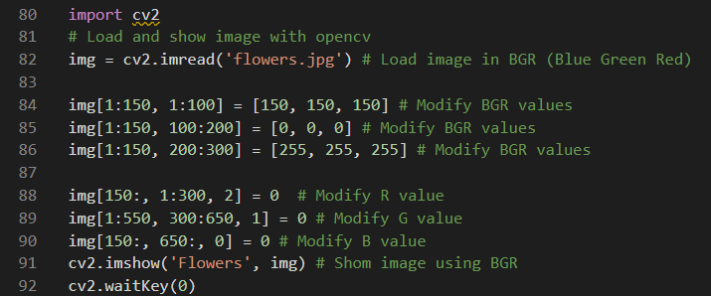
Figure 13. Load and modifying pixel values
Remember, to put your image file in the same directory as our python file. As we can see from the above code, we can access and modify pixel values from our image. We can access and modify its BGR values by accessing its row and column using the index. The first index represents pixel’s row and the second represents the column. We can reassign the pixel value into an integer between 0 and 255 since it’s a BGR value. We can also reassign only one of the BGR values by using indexing. We can add the third index which represents the pixel’s color we want to access or reassign. Remember, that the values are in BGR format which means accessing index 0 means accessing B color and index 2 for R color. Here is the image before and after we modify its values.

Figure 14. Flower image


Figure 15. Flower image after modified

References:
https://www.flickr.com/photos/alfon18/2493066758

